Nama : Siti Sa’adah
NIM 2403001
Kelas : D3 TI 2A
Mata Kuliah : Internet of Things

TUGAS PRAKTIKUM

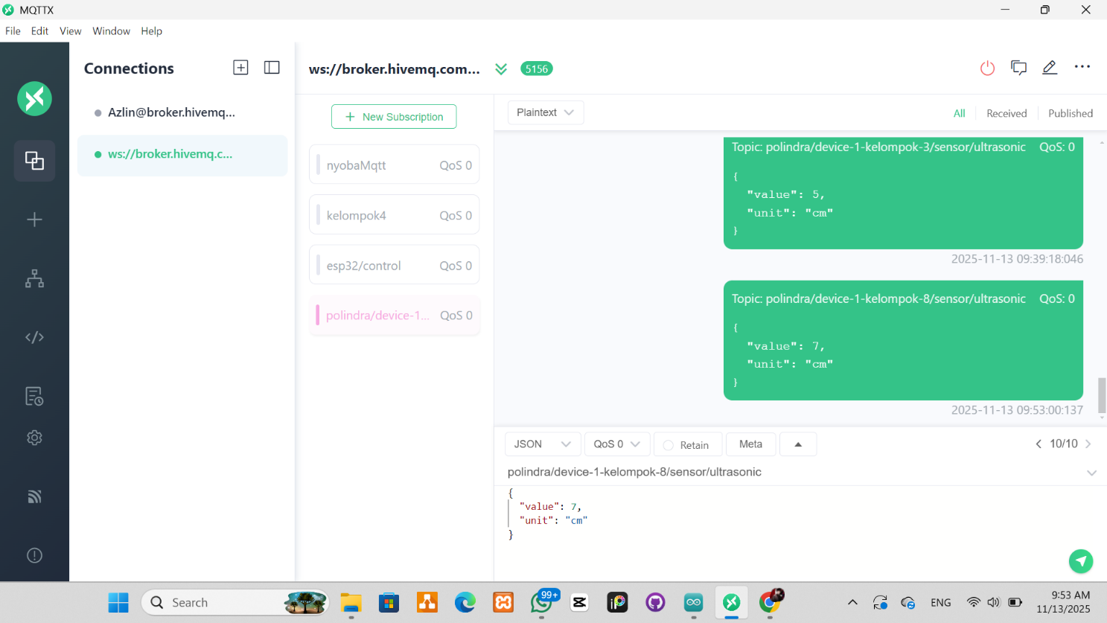

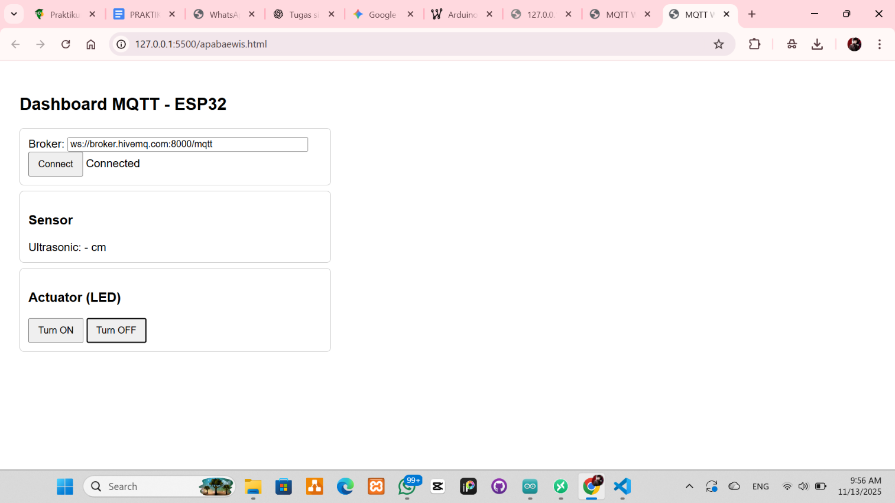

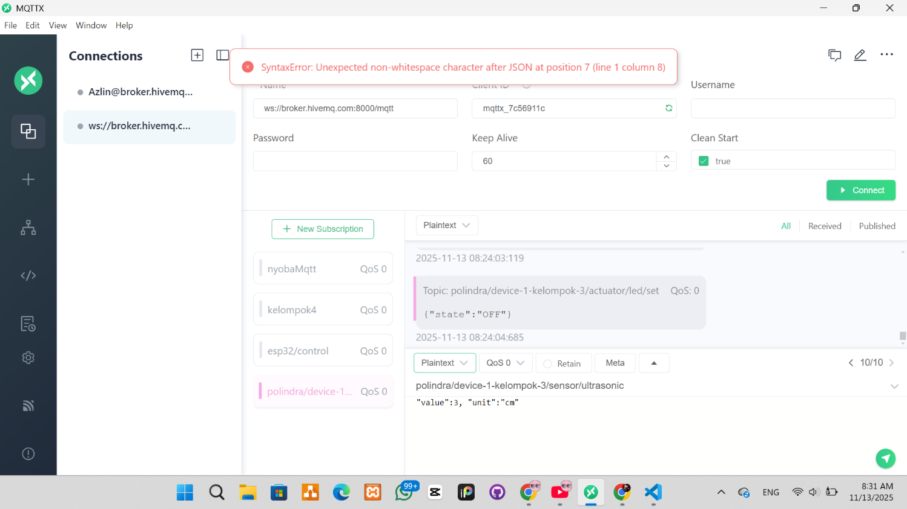

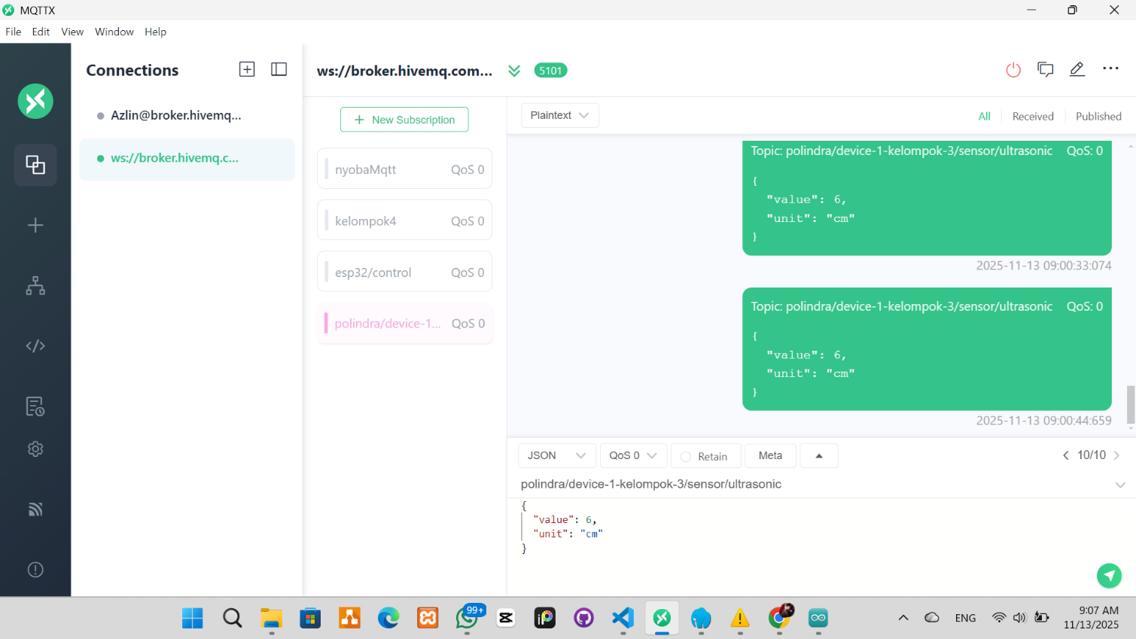

<!doctype html>
<html>
<head>
<meta charset="utf-8" />
<title>MQTT Web Dashboard</title>
<script src="https://unpkg.com/mqtt/dist/mqtt.min.js"></script>
<style>
body {
font-family: Arial, sans-serif;
padding: 20px;
}
.card {
border: 1px solid #ccc;
padding: 12px;
margin: 8px 0;
border-radius: 6px;
max-width: 420px;
}
button {
padding: 8px 12px;
}
</style>
</head>
<body>
<h2>Dashboard MQTT - ESP32</h2>
<div class="card">
<div>Broker: <input id="broker" value="ws://broker.hivemq.com:8000/mqtt" style="width:80%"></div>
<div><button id="connectBtn">Connect</button> <span id="connStatus">Disconnected</span></div>
</div>
<div class="card">
<h3>Sensor</h3>
<div>Ultrasonic: <span id="ultrasonic">-</span> cm</div>
</div>
<div class="card">
<h3>Actuator (LED)</h3>
<button id="ledOnBtn">Turn ON</button>
<button id="ledOffBtn">Turn OFF</button>
</div>
<script>
let client = null;
const deviceId = "device-1-kelompok-3";
const topics = {
ultrasonic: `polindra/${deviceId}/sensor/ultrasonic`,
ledSet: `polindra/${deviceId}/actuator/led/set`
};
function connect(brokerUrl) {
client = mqtt.connect(brokerUrl);
document.getElementById('connStatus').innerText = 'Connecting...';
client.on('connect', () => {
document.getElementById('connStatus').innerText = 'Connected';
client.subscribe(topics.ultrasonic);
});
client.on('message', (topic, payload) => {
try {
const msg = JSON.parse(payload.toString());
if (topic === topics.ultrasonic) {
document.getElementById('ultrasonic').innerText = msg.value;
} else if (topic === topics.lainnya) {
// silakan tambahkan logika untuk topic lainnya
}
} catch (e) {
console.log('Invalid JSON', payload.toString());
}
});
client.on('error', (err) => {
console.error(err);
document.getElementById('connStatus').innerText = 'Error';
});
client.on('close', () => {
document.getElementById('connStatus').innerText = 'Disconnected';
});
}
document.getElementById('connectBtn').addEventListener('click', () => {
const url = document.getElementById('broker').value;
connect(url);
});
document.getElementById('ledOnBtn').addEventListener('click', () => {
if (client && client.connected) {
client.publish(topics.ledSet, JSON.stringify({ state: "ON" }));
}
});
document.getElementById('ledOffBtn').addEventListener('click', () => {
if (client && client.connected) {
client.publish(topics.ledSet, JSON.stringify({ state: "OFF" }));
}
});
</script>
</body>
</html>

